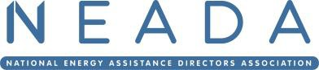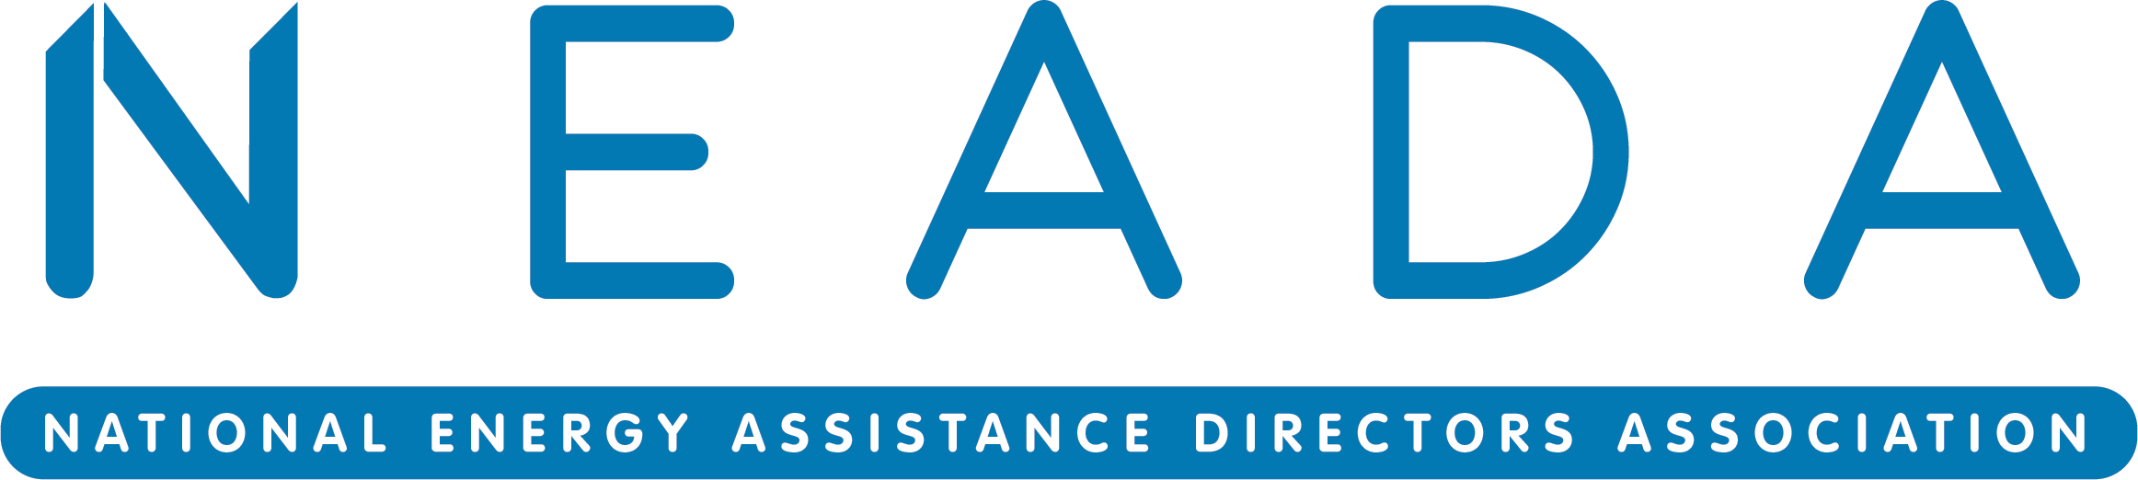

Registration Form
NEADA Winter Meeting – March 10-12, 2026
The True Reformer Building | 1200 U Street NW | Washington, DC 20009
Hotel details, credit card instructions, and agenda available at: https://neada.org/neada-meetings

Please return to smoradi@neada.org by February 23, 2026.
Organization/State Agency:
First Attendee Name:
Title:
Phone: Email:

Second Attendee Name:
Title:

Phone: Email:

Third Attendee Name:
Title:

Phone: Email:

Fourth Attendee Name:
Title:

Phone: Email:
Use additional forms to add more attendees.

2026 Winter Meeting Attendees (#) $850 each Method of Payment:
= $
☐ Check made payable to National Energy Assistance Directors Association
☐ Agency Authorization Voucher (send to smoradi@neada.org)
☐ Credit Card (https://neada.org/product/neada-winter-meeting-2026)

NEADA’s tax ID is 42-1445636. Send checks to: NEADA, P.O. Box 42655, Washington, D.C.
20015- 0655. Agenda, hotel, and credit card information available at https://neada.org/neada-meetings.

